### Question 1: Project, Features and Releases

### Question 3:

1. **Position Hierarchy:**

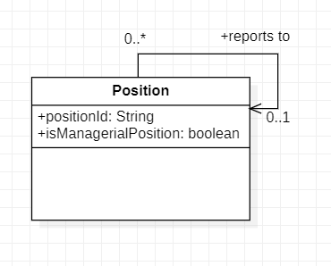

1. **Course Prerequisites:**

